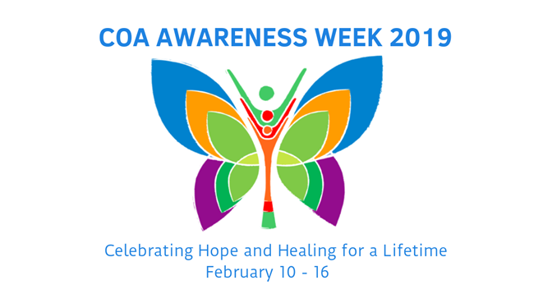

Celebrating Hope and Healing for a Lifetime

February 10 – 16

Social Media Toolkit

One of the quickest and easiest ways to raise awareness, educate the community and promote an event is through social media. By sharing images and messages on the social media channels you use regularly, you can help people in your community better understand the challenges facing COAs and their families and provide guidance on where they can find resources and learn more about how they can help. Additionally, through social media, you increase the likelihood of reaching children and teens directly, and letting them know they are not alone.

Remember to engage with NACoA throughout the week, as we’ll be sharing additional messages and additional resources!

**Guidelines and Disclaimer**

*COA Awareness Week graphics may be used for educational and informational purposes in relation to the advocacy week, and information found on* [***www.nacoa.org***](http://www.nacoa.org/)*. Use of COA Week Awareness images does not indicate any form of endorsement or approval from NACoA.*

Commonly used platforms: Facebook, Twitter, LinkedIn, Instagram. On the following pages, you’ll find campaign-themed images and sample social media posts. **Right click on any of these images to save them and use as needed!**

**PROFILE PICTURE**

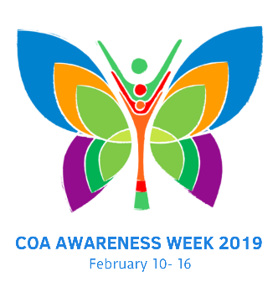

The image above can be used as a profile picture on social media challenges.

**FACEBOOK**

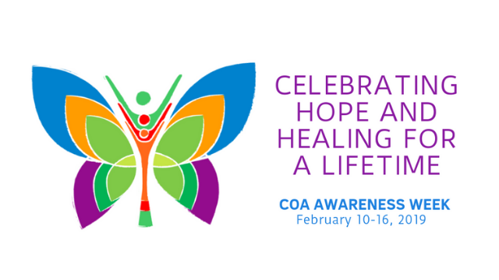

NACoA will be very active on Facebook during COA Awareness Week! Visit often for more ideas, or to share one of ours on your page. We will highlight event ideas, free resources to support children and to guide adults who want to help them, ways to get involved, and news about what people are doing to help children in local communities.

**Sample Facebook Posts**

* **#COAAwarenessWeek2019** is coming! Join us February 10-16 and raise awareness about children of addiction and join us in **#CelebratingHopeAndHealingForALifetime**! Learn more at<https://nacoa.org/coa-awareness-week/> **#COAWeek2019**  **#VoicefortheChildren**
* Whether **#alcohol**, **#opioids**, or other substances, the pain and anguish for children living with addiction is the same. BUT IT DOESN’T HAVE TO BE THAT WAY! Learn more during **#COAWeek2019** about how everyone has the ability to make the difference in the life of a **#COA.** <https://nacoa.org/coa-awareness-week/>
* Remember the 7 Cs: It is important for kids & teens to realize they didn’t cause the addiction, they can’t control it, and they can’t cure it. They can help take care of themselves by communicating their feelings, making healthy choices and celebrating what is good in themselves. **#COAWeek2019**  **#7Cs #CelebratingHopeAndHealingForALifetime** <https://nacoa.org/coa-awareness-week/>

* Kids and teens can heal from the impact of parental addiction with proper support and services. With the current opioid public health emergency, it is critical to bring hope and healing to the children now. **#COAAwarenessWeek2019**  **#CelebratingHopeAndHealingForALifetime** <https://nacoa.org/coa-awareness-week/>
* Together let’s bring hope and healing to children living with parental addiction! **#CelebratingHopeAndHealingForALifetime** **#COAWeek2019 #CaringAdult #Teachers #SchoolPsychologists #Pediatricians #YouthMinisters #DrugCourt** Learn more at<https://nacoa.org/coa-awareness-week/>
* Help children heal by breaking the silence and isolation of the unspoken rules: **#Don’tTalkDontFeelDontTrust** **#COAWeek2019** Learn more at<https://nacoa.org/coa-awareness-week/>

**TWITTER**

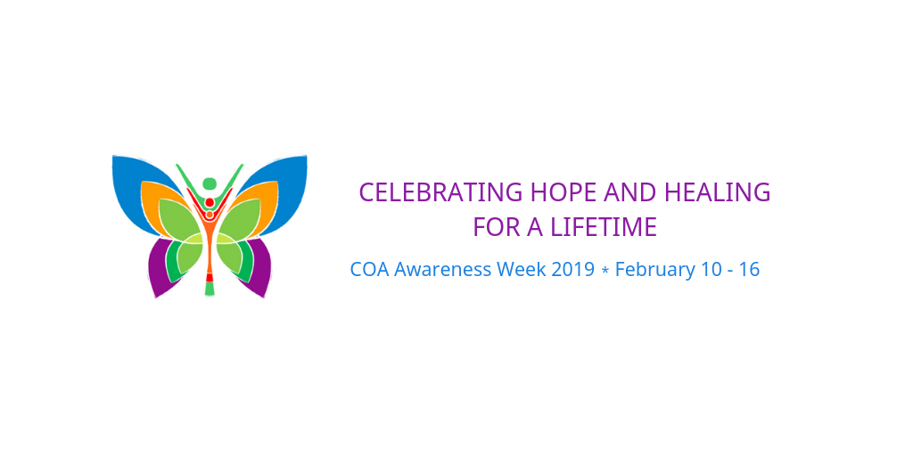

References to COA Awareness Week on Twitter can have a great impact on the community, especially since children and teens are more likely to use Twitter than Facebook. Help spread the word about COA Awareness Week with the hashtags: **#COAWeek2019, #ChildrenofAddictionWeek #CelebratingHopeAndHealingForALifetime** Consider sharing information during the week with hashtags that teenagers in your community use. Follow us throughout the week on Twitter (@NACoA_USA).

**Sample Tweets**

* Help support kids and teens at risk to become children of promise! **#COAWeek2019 #VoicefortheChildren** **#CelebratingHopeAndHealingForALifetime** <https://nacoa.org/coa-awareness-week/>
* Kids & **#teens** begin to heal when they embrace the **#7Cs**: I didn’t cause it. I can’t control it. I can’t cure it. I can help take care of myself by communicating my feelings, making healthy choices, and celebrating me. **#COAWeek2019 #Recovery #HelpAndHope**
* It only takes one **#CaringAdult** to change the trajectory of a child's life. Help **#MakeTheDifference** in the lives of children to last a lifetime **#COAWeek2019 #1in4** <https://nacoa.org/coa-awareness-week/>

**LINKEDIN**

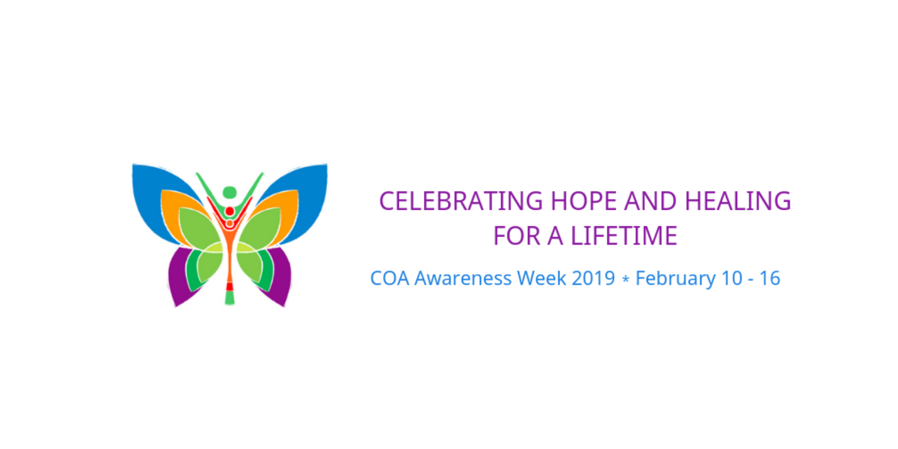

LinkedIn is the platform to better connect on social media with your colleagues, partners and fellow businesses in your community. An advocacy campaign like COA Awareness Week is a great way to increase your presence among your business and nonprofit peers, and guide them to your website, blogs and upcoming news and events. NACoA post resources during the week that can be shared!

**Sample Linked In Posts**

* **#COAAwarenessWeek2019** is coming! Join us February 10-16 and raise awareness about children of addiction and join us in **#CelebratingHopeAndHealingForALifetime**! Learn more at<https://nacoa.org/coa-awareness-week/> **#COAWeek2019**  **#VoicefortheChildren**
* Together let’s bring hope and healing to children living with parental addiction! **#CelebratingHopeAndHealingForALifetime** **#COAWeek2019 #CaringAdult #Teachers #SchoolPsychologists #Pediatricians #YouthMinisters #DrugCourt** Learn more at<https://nacoa.org/coa-awareness-week/>
* It only takes one **#CaringAdult** to change the trajectory of a child's life. Help **#MakeTheDifference** in the lives of children to last a lifetime **#COAWeek2019 #1in4** <https://nacoa.org/coa-awareness-week/>

**INSTAGRAM / PINTEREST**

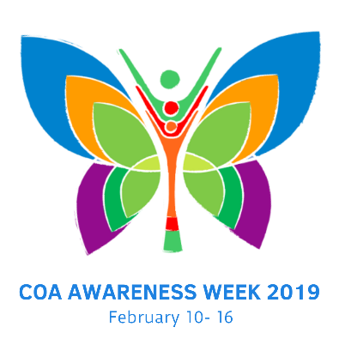

As the platform preferred by many teens and young adults, Instagram is a great way to reach out to today’s youth and remind them they are not alone. Pinterest is another great platform with a strong visual presence and sharing on there might grab the attention of someone who isn’t aware of COA Awareness Week.