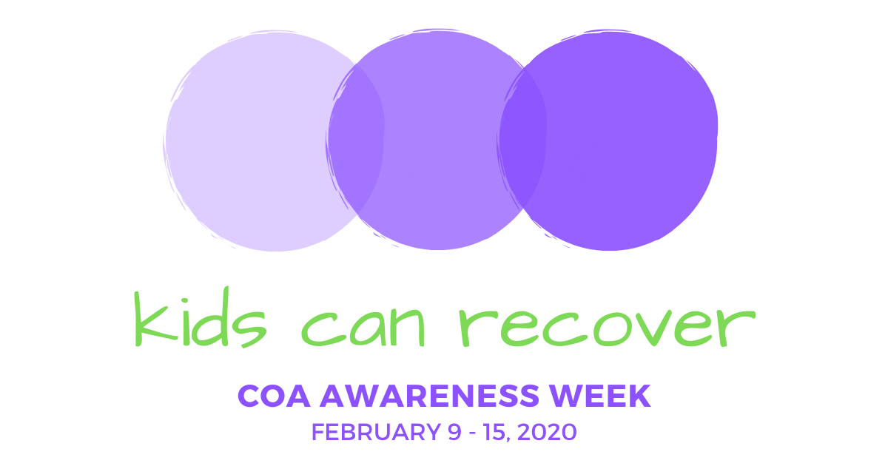
Social Media Toolkit

One of the quickest and easiest ways to raise awareness, educate the community and promote an event is through social media. By sharing images and messages on the social media channels you use regularly, you can help people in your community better understand the challenges facing COAs and their families and provide guidance on where they can find resources and learn more about how they can help. Additionally, through social media, you increase the likelihood of reaching children and teens directly, and letting them know they are not alone.

Remember to engage with NACoA throughout the week, as we’ll be sharing additional messages and additional resources!

Guidelines and Disclaimer
COA Awareness Week graphics may be used for educational and informational purposes in relation to the advocacy week, and information found on www.nacoa.org. Use of COA Week Awareness images does not indicate any form of endorsement nor approval from NACoA.

Commonly used platforms: Facebook, Twitter, LinkedIn, Instagram. On the following pages, you’ll find campaign-themed images and sample social media posts. Right click on any of these images to save them and use as needed!

Horizonal Image

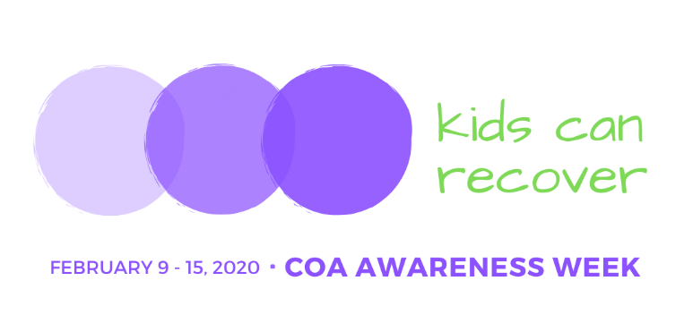

vertical Image SOCIAL MEDIA PROFILE IMAGE
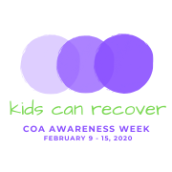

The image above can be used as a profile picture on social media.

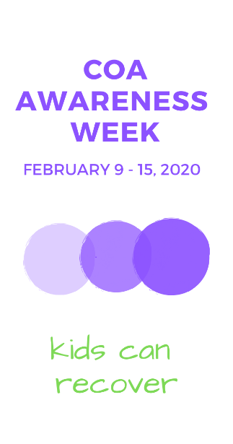

FACEBOOK

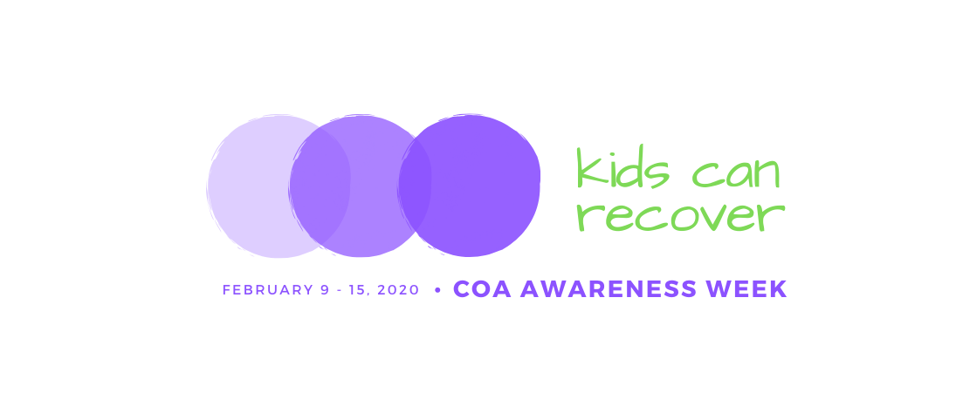

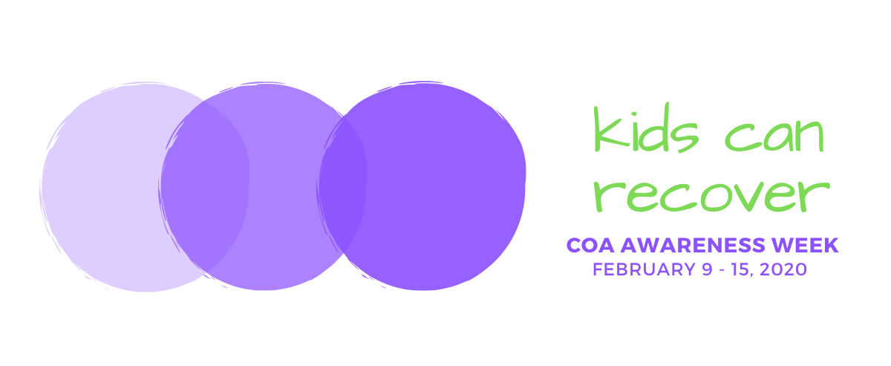
The images above can be used for Facebook cover images.

NACoA will be very active on Facebook during COA Awareness Week! Visit often for more ideas, or to share one of ours on your page. We will highlight event ideas, free resources to support children and to guide adults who want to help them, ways to get involved, and news about what people are doing to help children in local communities.

Sample Facebook Posts

- #COAAwarenessWeek2020 is coming! Join us February 9-15 and raise awareness about #ChildrenOfAddiction! #KidsCanRecover from the impact of #ParentalAddiction. Learn more at https://nacoa.org/coa-awareness-week/ #COAWeek2020 #COAs #VoicefortheChildren
- Regardless if it is #alcohol, #opioids, or other substances being misused, the impact on children living with addiction is the same. BUT IT DOESN’T HAVE TO BE THAT WAY! #BuildResilienceInKids Learn more about how #KidsCanRecover. #COAWeek2020 https://nacoa.org/coa-awareness-week/
- Together let’s help children living with parental addiction heal! #KidsCanRecover #COAWeek2020 #CaringAdult #Teachers #SchoolPsychologists #Pediatricians #YouthMinisters #DrugCourt Learn more https://nacoa.org/coa-awareness-week/
- #KidsCanRecover by breaking the silence and isolation of the unspoken rules: #Don’tTalkDontFeelDontTrust #COAWeek2020 Learn more https://nacoa.org/coa-awareness-week/
- Kids and teens can heal from the impact of #ParentalAddiction with proper support and services. With one caring and supportive adult, #KidsCanRecover #COAAwarenessWeek2020 https://nacoa.org/coa-awareness-week/

TWITTER
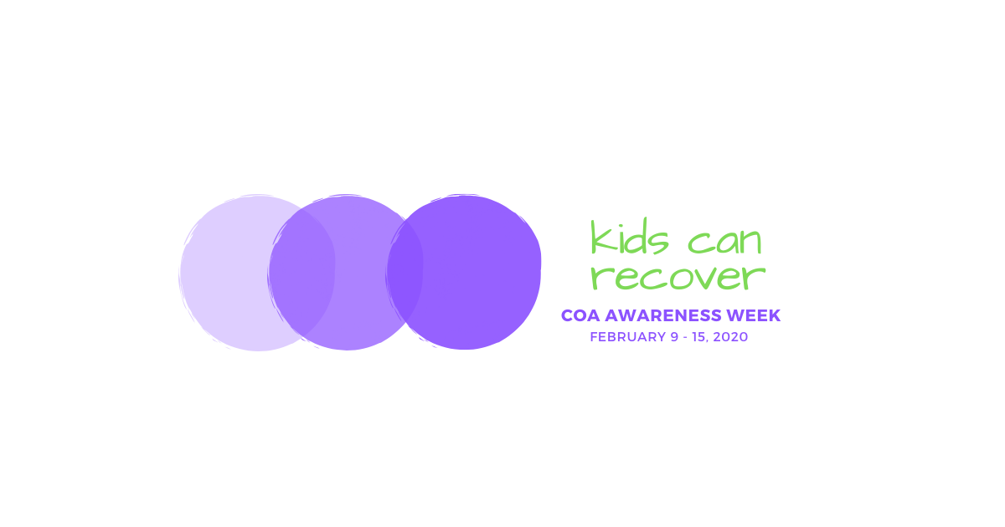

The image above can be used for a Twitter cover image.

References to COA Awareness Week on Twitter can have a great impact on the community. Remember ‘tweeners and teens are more likely to use Twitter than Facebook.

Help spread the word about COA Awareness Week with the hashtags:
#COAWeek2020
#COAAwarenessWeek2020
#KidsCanRecover
#BeASourceofHopeHelpAndHealing
#BuildResilienceInKids

Consider sharing information during the week with hashtags that teenagers in your community might use. Follow us throughout the week on Twitter (@NACoA_USA).

Sample Tweets

- Support and services today help build a healthier tomorrow for children impacted by #ParentalAddiction. #KidsCanRecover #COAAwarenessWeek2020 #BuildResilienceInKids https://nacoa.org/coa-awareness-week/
- 1 in 4 children are impacted by #ParentalAddiction. The fear and isolation is real, but with support and services #KidsCanRecover #COAAwareness2020
- #BeTheSafePerson for a teen living with #Parental Addiction. #BeASourceofHopeHelpAndHealing #LetThemKnowYouCare #COAWeek2020 https://nacoa.org/coa-awareness-week/

LINKEDIN
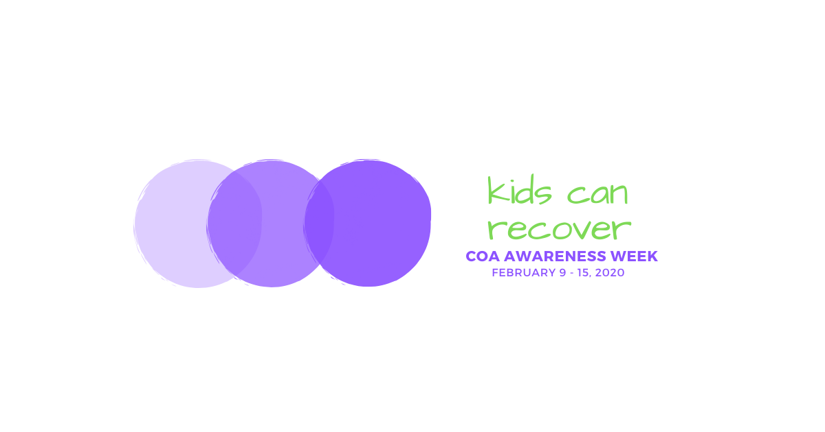

LinkedIn is the platform to better connect on social media with your colleagues, partners and fellow businesses in your community. An advocacy campaign like COA Awareness Week is a great way to increase your presence among your business and nonprofit peers, and guide them to your website, blogs and upcoming news and events. NACoA will additionally post resources during the week that can be shared!

Sample Linked In Posts

- #COAAwarenessWeek2020 is coming! Join us February 9-15 and raise awareness about children of addiction because #KidsCanRecover! Learn more at https://nacoa.org/coa-awareness-week/ #COAWeek2020 #VoicefortheChildren
- It only takes one #CaringAdult to change the trajectory of a child's life. #BeASourceofHopeHelpAndHealing #BuildResilienceInKids #COAWeek2020 #1in4 https://nacoa.org/coa-awareness-week/
- Together let’s bring hope, help, & healing to children living with parental addiction! #CelebratingHopeAndHealingForALifetime #COAWeek2020 #CaringAdult #Teachers #SchoolPsychologists #Pediatricians #YouthMinisters #DrugCourt Learn more at https://nacoa.org/coa-awareness-week/

INSTAGRAM / PINTEREST

As the platform preferred by many teens and young adults, Instagram is a great way to reach out to today’s youth and remind them they are not alone. Pinterest is another great platform with a strong visual presence and sharing on there might grab the attention of someone who isn’t aware of COA Awareness Week.

To help promote the campaign:
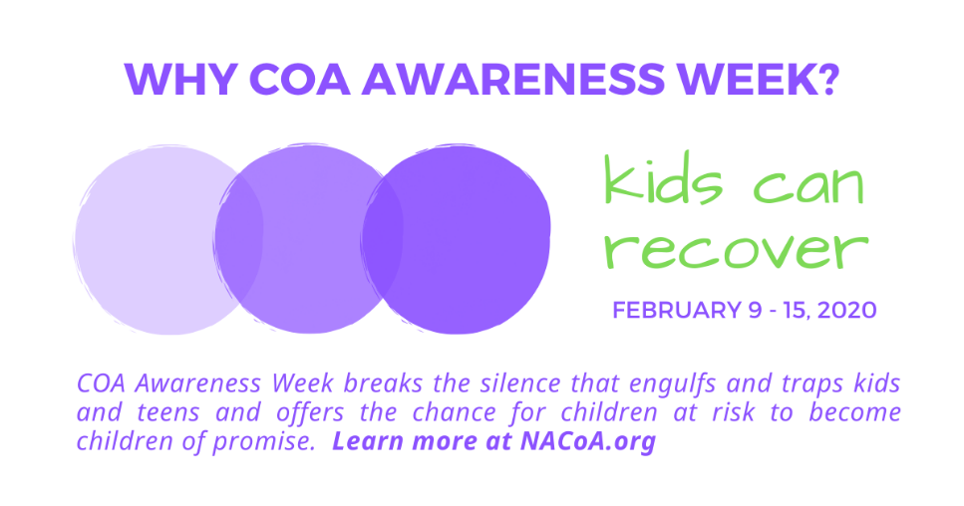
Share this image prior to the week to help spread the word.

Provide a Facebook Live video, or take a short video with your cell phone, and then post it, talking about Why COA Awareness Week. Or share the one of a number that will be provided building up to the week to help promote COA Awareness Week.

During COA Awareness Week, visit NACoA’s Facebook, Twitter or Linked In pages. Remember we’ll be sharing additional information and announcements all week long!

