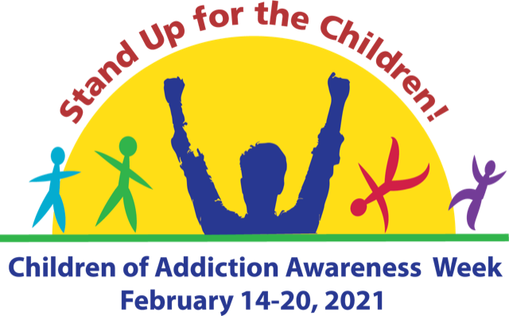

Social Media Toolkit

One of the quickest and easiest ways to raise awareness, educate the community and promote an event is through social media. By sharing images and messages on the social media channels you use regularly, you can help people in your community better understand the challenges facing COAs and their families and provide guidance on where they can find resources and learn more about how they can help. Additionally, through social media, you increase the likelihood of reaching children and teens directly and letting them know they are not alone.

Remember to engage with NACoA throughout the week, as we’ll be sharing additional messages and additional resources!

Guidelines and Disclaimer
COA Awareness Week graphics may be used for educational and informational purposes in relation to the advocacy week, and information found on Nacoa.org. Use of COA Week Awareness images does not indicate any form of endorsement nor approval from NACoA.

Commonly used platforms: Facebook, Twitter, LinkedIn, Instagram. On the following pages, you’ll find campaign-themed images and sample social media posts. Right click on any of these images to save them and use as needed!

Horizonal Image

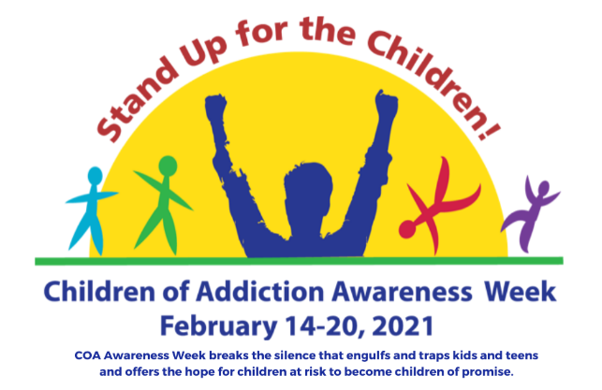

vertical Image SOCIAL MEDIA PROFILE IMAGE

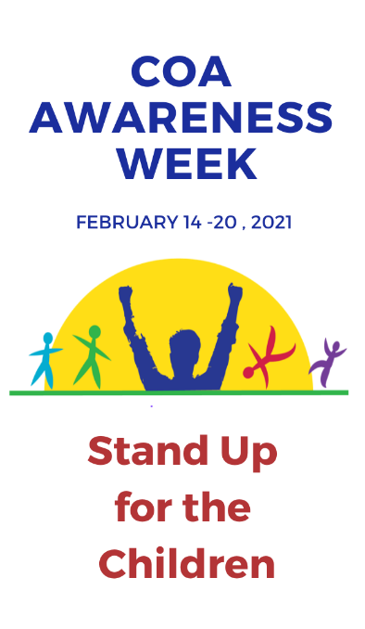
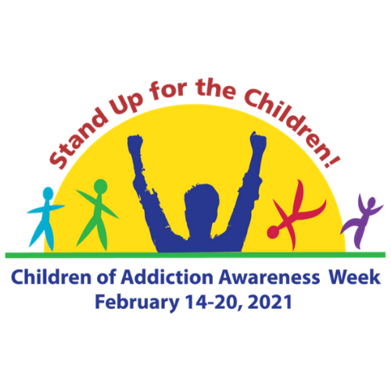

The image above can be used as
a profile picture on social media.

FACEBOOK

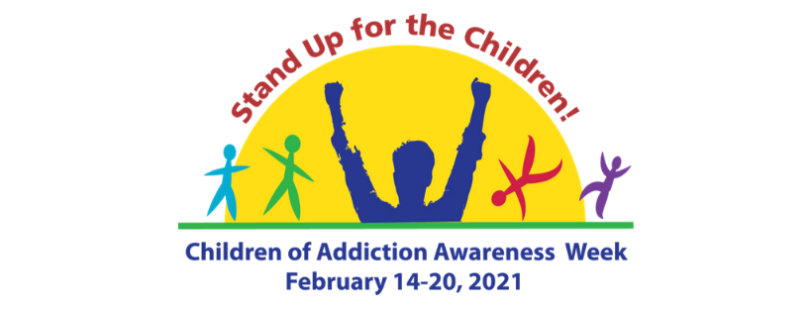
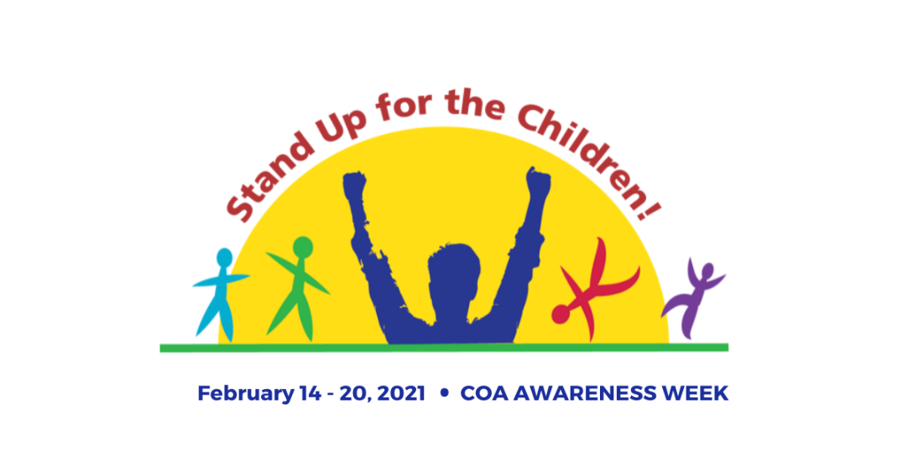
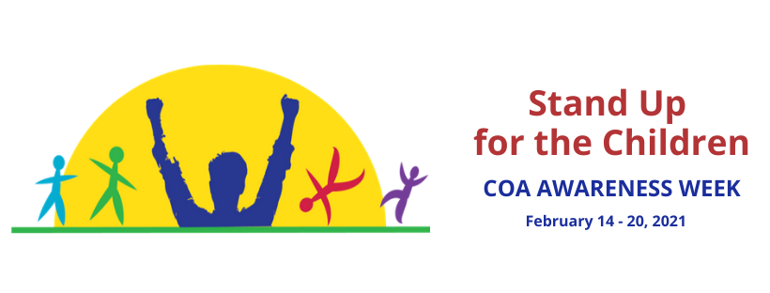

The images above can be used for Facebook cover images.

NACoA will be very active on Facebook during COA Awareness Week! Visit often for more ideas, or to share one of ours on your page. We will highlight event ideas, free resources to support children and to guide adults who want to help them, ways to get involved, and news about what people are doing to help children in local communities.

Sample Facebook Posts

- #COAAwarenessWeek2021 is coming! Join us February 14-20 and raise awareness about #ChildrenOfAddiction! #StandUpForTheChildren from the impact of #ParentalAddiction. Learn more at https://nacoa.org/coa-awareness-week/ #COAWeek2021 #COAs #VoicefortheChildren
- Kids and Teens are more isolated than ever with online school and most after school activities cancelled until communities can reopen. #StandUpForTheChildren and let them know they are not alone, and that you care. #COAWeek2021 https://nacoa.org/coa-awareness-week/
- Regardless if it is #alcohol, #opioids, or other substances being misused, the impact on children living with addiction is the same. BUT IT DOESN’T HAVE TO BE THAT WAY! Learn more about how to #StandUpForTheChildren. #COAWeek2021 https://nacoa.org/coa-awareness-week/
- Together let’s help children living with parental addiction heal! #COAWeek2021 #CaringAdult #Teachers #SchoolPsychologists #Pediatricians #YouthMinisters #DrugCourt Learn more https://nacoa.org/coa-awareness-week/
- #StandUpForTheChildren and help break the silence and isolation of the unspoken rules: #Don’tTalkDontFeelDontTrust #COAWeek2021 Learn more https://nacoa.org/coa-awareness-week/
- Kids and teens can heal from the impact of #ParentalAddiction with proper support and services. But they can’t do it alone. Caring and supportive adults can #StandUpForTheChildren #COAAwarenessWeek2021 https://nacoa.org/coa-awareness-week/

TWITTER

The image above can be used for a Twitter cover image.

References to COA Awareness Week on Twitter can have a great impact on the community. Remember ‘tweeners and teens are more likely to use Twitter than Facebook.

Help spread the word about COA Awareness Week with the hashtags:
#COAWeek2021
#COAAwarenessWeek2021
#StandUpForTheChildren
#CaringAdult

Consider sharing information during the week with hashtags that teenagers in your community might use. Follow us throughout the week on Twitter (@NACoA_USA).

Sample Tweets

- #StandUpForTheChildren who are impacted by #ParentalAddiction. #COAs #COAAwarenessWeek2021 https://nacoa.org/coa-awareness-week/
- 1 in 4 children are impacted by #ParentalAddiction. The fear and isolation is real, but IT DOESN’T HAVE TO BE THAT WAY. #LetThemKnowYouCare #COAAwareness2021
- Provide the hope and healing to kids impacted by #ParentalAddiction. They need to know you care, before they care about what you know. #COAWeek2021 https://nacoa.org/coa-awareness-week/

LINKEDIN
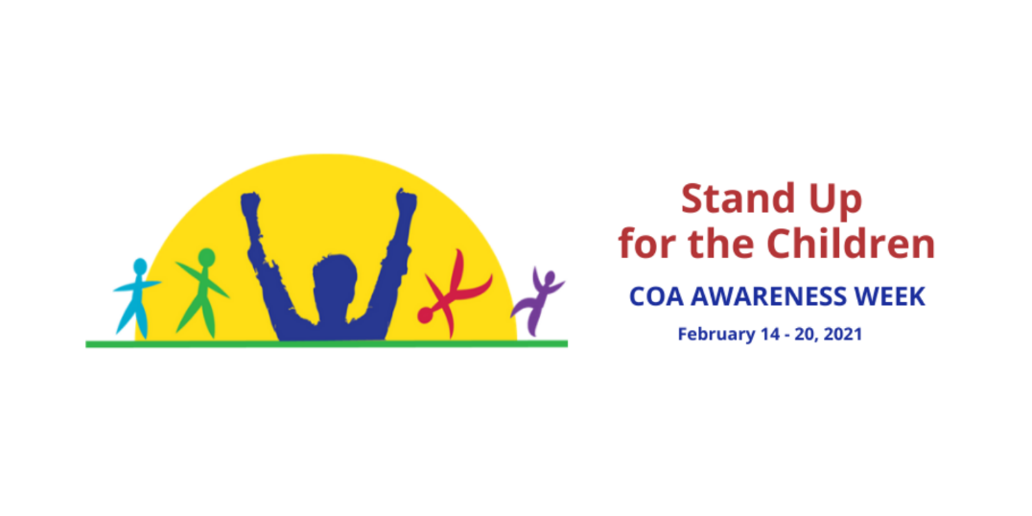

LinkedIn is the platform to better connect on social media with your colleagues, partners and fellow businesses in your community. An advocacy campaign like COA Awareness Week is a great way to increase your presence among your business and nonprofit peers, and guide them to your website, blogs and upcoming news and events. NACoA will additionally post resources during the week that can be shared!

Sample Linked In Posts

- #COAAwarenessWeek2021 is coming! Join us February 14 - 20 and raise awareness about children of addiction and #StandUpForTheChildren. Learn more at https://nacoa.org/coa-awareness-week/ #COAWeek2021
- It only takes one #CaringAdult to change the trajectory of a child's life. #COAWeek2021 #1in4 https://nacoa.org/coa-awareness-week/
- Kids and teens can heal from the impact of #ParentalAddiction with proper support and services. But they can’t do it alone. Caring and supportive adults can #StandUpForTheChildren #COAAwarenessWeek2021 https://nacoa.org/coa-awareness-week/
- Together let’s #StandUpForTheChildren impacted by #ParentalAddiction #COAWeek2021 #CaringAdult #Teachers #SchoolPsychologists #Pediatricians #YouthMinisters #DrugCourt Today they are isolated and alone, but tomorrow can be different when caring adults provide help and healing. Learn more at https://nacoa.org/coa-awareness-week/

INSTAGRAM / PINTEREST

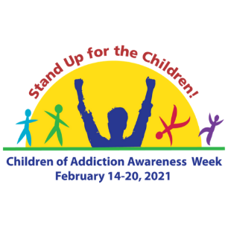
As the platform preferred by many teens and young adults, Instagram is a great way to reach out to today’s youth and remind them they are not alone. Pinterest is another great platform with a strong visual presence and sharing on there might grab the attention of someone who isn’t aware of COA Awareness Week.

To help promote the campaign:
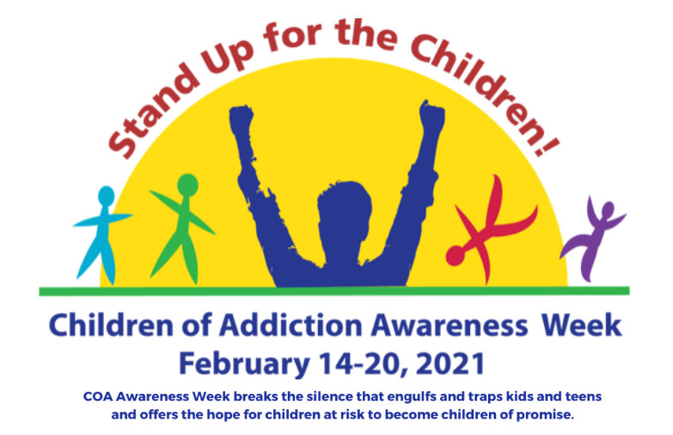
Share this image to help spread the word.

Provide a Facebook Live video, or take a short video with your cell phone, and then post it, talking about Why COA Awareness Week is more important in 2021 than in year’s past.

During COA Awareness Week, visit NACoA’s Facebook, Twitter or Linked In pages. Remember we’ll be sharing additional information and announcements all week long!

